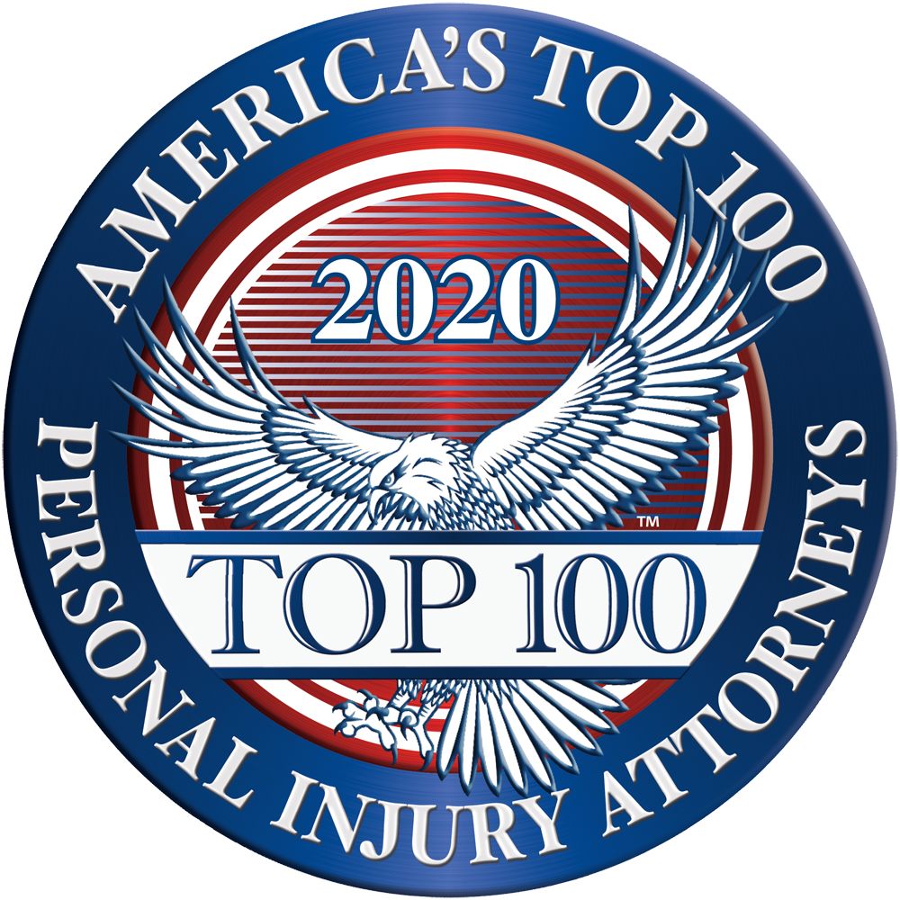
Contact Kevin Wieser – Membership Director  Telephone (714) 409-8126  Email Membership@AmericasTop100Attorneys.com  Website www.Top100PersonalInjuryAttorneys.com | FOR IMMEDIATE RELEASE

AMERICA’S top 100 PERSONAL INJURY ATTORNEYS®

November 6, 2020 – Announcing the selection of William Kendig among America’s Top 100 Personal Injury Attorneys® for 2020. Selection to America’s Top 100 Personal Injury Attorneys® is by invitation only and is reserved to identity the nation’s most exceptional litigators for high-value personal injury, catastrophic injury, wrongful death, product liability, and medical malpractice matters.
To be considered for selection, an attorney must focus more than 50% of their active legal practice on personal injury, catastrophic injury, wrongful death, product liability, and/or medical malpractice matters. These minimum qualifications are required for initial consideration. Thereafter, candidates are carefully screened through Advanced Data Analytics evaluating a broad array of criteria, including the candidate’s professional experience, litigation experience, significant personal injury settlements and/or verdicts, peer reputation, and community impact in order to rank the candidates throughout the state.
Only the top 100 qualifying attorneys in each state will receive this honor and be selected for membership among America’s Top 100 Personal Injury Attorneys®. With these extremely high standards for selection to America’s Top 100 Personal Injury Attorneys®, less than one-half percent (0.5%) of active attorneys in the United States will receive this honor — truly the most exclusive and elite level of attorneys in the community.

